You have n binary tree nodes numbered from 0 to n - 1 where node i has two children leftChild[i] and rightChild[i], return true if and only if **all** the given nodes form **exactly one** valid binary tree.

If node i has no left child then leftChild[i] will equal -1, similarly for the right child.

Note that the nodes have no values and that we only use the node numbers in this problem.

**Example 1:**

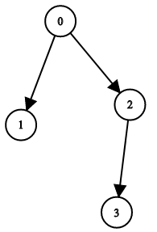

Input: n = 4, leftChild = [1,-1,3,-1], rightChild = [2,-1,-1,-1]  
Output: true

**Example 2:**

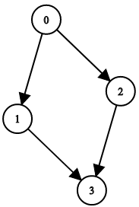

Input: n = 4, leftChild = [1,-1,3,-1], rightChild = [2,3,-1,-1]  
Output: false

**Example 3:**

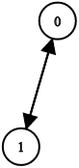

Input: n = 2, leftChild = [1,0], rightChild = [-1,-1]  
Output: false

**Constraints:**

* n == leftChild.length == rightChild.length
* 1 <= n <= 104
* -1 <= leftChild[i], rightChild[i] <= n - 1